# University of Cape Town

# Department of Oceanography

# 1st Semester 2016 EXAMINATION

# SEA2004F – PRINCIPLES OF OCEANOGRAPHY

INSTRUCTIONS : Attempt all questions.

TIME : 3 hours

(Total: 155 marks)

(The Final Exam counts 60% towards your final mark for the course).**SECTION A: (3 marks per question – TOTAL = 30 marks)**

1. Give a sketch of a typical current meter mooring. Is it classified as Eulerian or Lagrangian form of measurement?

Eulerian - measurements at a fixed location. Examples: single profiles, moored instruments, satellites, spatial averages of Lagrangian measurements

Lagrangian - measurements following the flow. Examples: drifters, floats

Time series - measurements over time, usually at regular intervals, long enough for spectral analysis of frequency content

Synoptic – “snapshot”

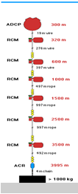

2. What is meant by the term “Carbonate Compensation Depth”?

Calcite compensation depth (CCD) is the depth in the oceans below which the rate of supply of calcite (calcium carbonate) lags behind the rate of solvation, such that no calcite is preserved.

Carbonate Compensation Depth is the particular depth level in the oceans where the rate of supply of calcium carbonate to the sea floor is balanced by the rate of dissolution.

Calcium carbonate is essentially insoluble in sea surface waters today. Shells of dead calcareous plankton sinking to deeper waters are practically unaltered until reaching the lysocline where the solubility increases dramatically. By the time the CCD is reached all calcium carbonate has dissolved. This explains why calcareous ooze dominates shallow areas because it does not dissolve at a high rate.

3. With the aid of a diagram explain how the pycnocline influences dissolved oxygen concentrations?

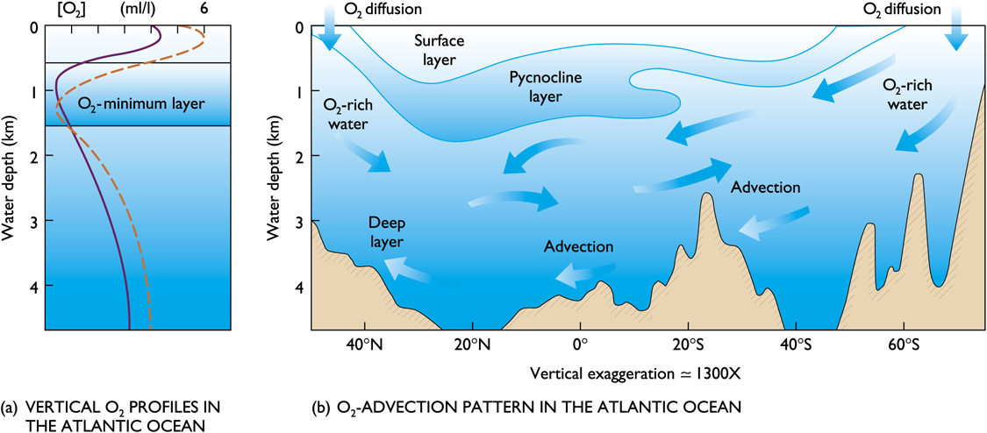

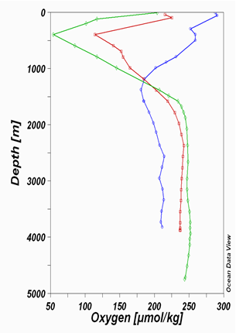

Oxygen tends to be abundant in the surface layer and deep layer bottom, but lowest in the pycnocline. Surface layer is rich in oxygen because of photosynthesis and contact with the atmosphere.

Oxygen minimum layer occurs at about 150 to 1500m below the surface and coincides with the pycnocline. Sinking food particles settle into this layer. The food draws large numbers of organisms which respire, consuming oxygen. Decay of uneaten material consumes additional oxygen.

Density difference prevents mixing downward of oxygen-rich water from the surface or upwards from the deep layer.

The deep layer is rich in oxygen because its water is cold and under pressure. Consumption is low because there are fewer organisms and less decay consuming oxygen. Anoxic waters contain no oxygen and are inhabited by anaerobic organisms (bacteria).

4. Coastal waters are often highly productive with abundant plankton organisms thriving in the surface waters. Why then are biogenous oozes rarely found in coastal waters?

The large input of terrigenous (made of material eroded from the land) sediment to the continental margin overwhelms the biogenous component in the sediment.

5. With the aid of two diagrams, explain where you would expect to find two large scale upwelling systems in the open ocean.

The major upwellings in the ocean are associated with the divergence of currents that bring deeper, colder, nutrient rich waters to the surface.

Equatorial - Upwelling at the equator is associated with the Intertropical Convergence Zone (ITCZ) which actually moves, and consequently, is often located just north or south of the equator. Easterly (westward) trade winds blow from the Northeast and Southeast and converge along the equator blowing West to form the ITCZ. Although there are no Coriolis forces present along the equator, upwelling still occurs just north and south of the equator. This results in a divergence, with denser, nutrient-rich water being upwelled from below.

Southern Ocean - Large-scale upwelling is also found in the Southern Ocean. Here, strong westerly (eastward) winds blow around Antarctica, driving a significant flow of water northwards. Since there are no continents in a band of open latitudes between South America and the tip of the Antarctic Peninsula, some of this water is drawn up from great depths. In many numerical models and observational syntheses, the Southern Ocean upwelling represents the primary means by which deep dense water is brought to the surface.

6. What is meant by the term “Western Boundary Current Intensification”? Compare the nature of Western Boundary Currents to those of Eastern Boundary Currents. Give an example of each.

Boundary currents are ocean currents with dynamics determined by the presence of a coastline, and fall into two distinct categories: western boundary currents and eastern boundary currents.

Eastern boundary currents are relatively shallow, broad and slow-flowing. They are found on the eastern side of oceanic basins (adjacent to the western coasts of continents). Subtropical eastern boundary currents flow equatorward, transporting cold water from higher latitudes to lower latitudes; examples include the Benguela Current, the Canary Current, the Humboldt Current, and the California Current. Coastal upwelling often brings nutrient-rich water into eastern boundary current regions, making them productive areas of the ocean.

Western boundary currents are warm, deep, narrow, and fast flowing currents that form on the west side of ocean basins due to western intensification. They carry warm water from the tropics poleward. Examples include the Gulf Stream, the Agulhas Current, and the Kuroshio.

Western intensification is the intensification of the western arm of an oceanic current, particularly a large gyre in an ocean basin. The trade winds blow westward in the tropics, and the westerlies blow eastward at mid-latitudes. This wind pattern applies a stress to the subtropical ocean surface with negative curl in the northern hemisphere and a positive curl in the southern hemisphere. The resulting Sverdrup transport is equatorward in both cases. It is because of western intensification that the currents on the western boundary of a basin are stronger than those on the eastern boundary.

7. Define a **deep** and **shallow** water wave in terms of the relationship between wavelength and water depth. Give the equation for the speed (celerity) of a **shallow** water wave.

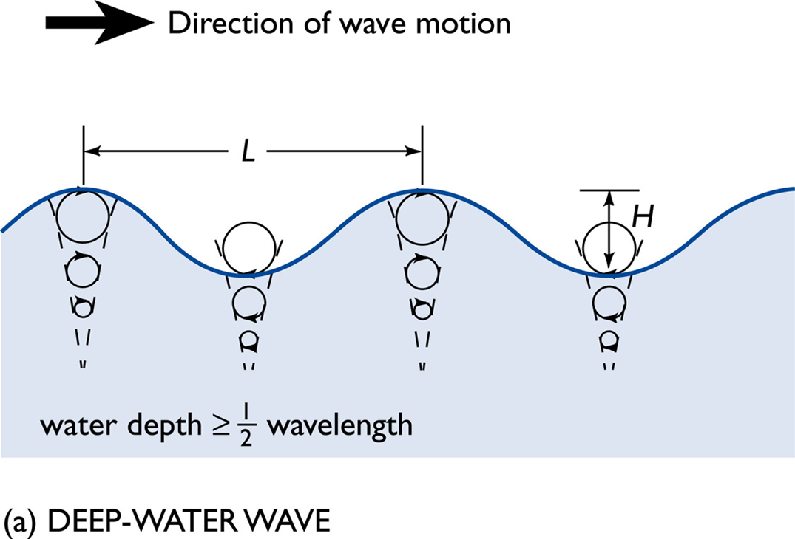

Deep Ocean:

Waves do not interact with the seafloor. Orbits of the water molecules are circular.

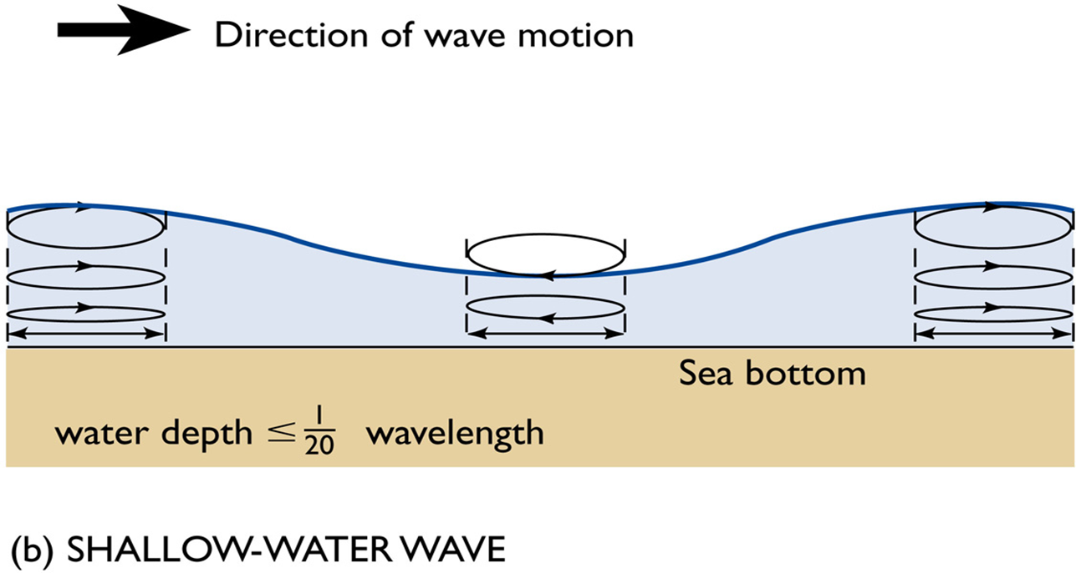Shallow Ocean:

Waves interact with the seafloor are known as Orbits of the water molecules become elliptical.

where

c is wave speed

g is gravity = 9.8m/s2

L is wavelength

d is depth

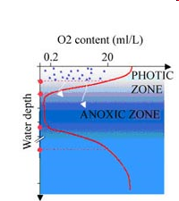8. The following is a typical profile for dissolved oxygen in the water column. Why is the dissolved oxygen concentration high in surface waters, low in the anoxic zone and high again at depth?

Oxygen tends to be abundant in the surface layer and deep layer bottom, but lowest in the pycnocline. Surface layer is rich in oxygen because of photosynthesis and contact with the atmosphere.

Oxygen minimum layer occurs at about 150 to 1500m below the surface and coincides with the pycnocline. Sinking food particles settle into this layer. The food draws large numbers of organisms which respire, consuming oxygen. Decay of uneaten material consumes additional oxygen.

Density difference prevents mixing downward of oxygen-rich water from the surface or upwards from the deep layer.

The deep layer is rich in oxygen because its water is cold and under pressure. Consumption is low because there are fewer organisms and less decay consuming oxygen. Anoxic waters contain no oxygen and are inhabited by anaerobic organisms (bacteria).

9. Define the following terms:

Solubility pump:

A physico-chemical process that transports carbon (as dissolved inorganic carbon) from the ocean's surface to its interior. The solubility pump is driven by the coincidence of two processes in the ocean.

* The solubility of carbon dioxide is a strong inverse function of seawater temperature (i.e. solubility is greater in cooler water).
* The thermohaline circulation is driven by the formation of deep water at high latitudes where seawater is usually cooler and denser

Since deep water (that is, seawater in the ocean's interior) is formed under the same surface conditions that promote carbon dioxide solubility, it contains a higher concentration of dissolved inorganic carbon than might be expected from average surface concentrations. Consequently, these two processes act together to pump carbon from the atmosphere into the ocean's interior.

Biological pump:

The ocean's biologically driven sequestration of carbon from the atmosphere to deep sea water and sediment. It is the part of the oceanic carbon cycle responsible for the cycling of organic matter formed mainly by phytoplankton during photosynthesis (soft-tissue pump), as well as the cycling of calcium carbonate (CaCO3) formed into shells by certain organisms such as plankton and mollusks (carbonate pump).

Once this carbon is fixed into soft or hard tissue, the organisms either stay in the euphotic zone to be recycled as part of the regenerative nutrient cycle or once they die, continue to the second phase of the biological pump and begin to sink to the ocean floor. The sinking particles will often form aggregates as they sink, greatly increasing the sinking rate. It is this aggregation that gives particles a better chance of escaping predation and decomposition in the water column and eventually make it to the sea floor.

The fixed carbon that is either decomposed by bacteria on the way down or once on the sea floor then enters the final phase of the pump and is remineralized to be used again in primary production. The particles that escape these processes entirely are sequestered in the sediment and may remain there for millions of years. It is this sequestered carbon that is responsible for ultimately lowering atmospheric CO2.

Whole ocean alkalinity:

Alkalinity is the name given to the quantitative capacity of an aqueous solution to neutralize an acid.[1] Measuring alkalinity is important in determining a stream's ability to neutralize acidic pollution from rainfall or wastewater. It is one of the best measures of the sensitivity of the stream to acid inputs.[2] There can be long-term changes in the alkalinity of streams and rivers in response to human disturbances.[3]

Alkalinity is related to the pH of a solution (its basicity), but measures a different property. Roughly, the alkalinity of a solution is a measure of how "strong" the bases are in a solution, whereas the pH measures the "amount" of chemical bases. A good example is a buffer solution, which can have many available bases (high alkalinity) despite having only a moderate pH level.

10. Name and briefly describe one method for measuring the particulate organic carbon flux out of surface waters. State a potential shortcoming/limitation of this method.

The Joint Global Ocean Flux Study (JGOFS) - Measurements using multiple neutrally-buoyant Langrangian sediment traps. Sediment traps only characteristic of a small area and require significant time to collect data.

**SECTION B: (25 marks per question – Total 125 marks)**

**1a)** What is meant by the terms “thermocline”, “halocline” and “pycnocline”? [5]

* thermocline – a rapid change in temperature with depth
* halocline – a rapid change in salinity with depth
* pycnocline – a rapid change in density with depth

**b)** Figure 1 overleaf depicts the distribution of salinity in the Atlantic Ocean from 65°N to 68°S. Using this figure draw a **vertical** salinity profile for each station occupied at 30°S, 0°, 65°S and 35°N. Explain why these profiles differ with latitude. [12]

Because freshening and salinification occur in different places, salinity at a particular location reflects the upstream source of the water there. In subtropical latitudes, high surface evaporation creates high salinity near the sea surface. In subpolar latitudes, high precipitation creates low salinity near the sea surface. As these waters flow into the ocean interior, they create layers of high and low salinity.

At mid-depth (i.e., around 1000 to 2000 m deep), outflows from the highly evaporative Mediterranean and Red Seas create a vertical salinity maximum in the North Atlantic and Indian Oceans, respectively. Also at mid-depth in the subtropical and tropical regions, the relatively fresh, but dense, surface water from higher latitudes flows in and creates a vertical salinity minimum, most prevalent in the Southern Hemisphere and North Pacific. The North Atlantic is the most saline ocean and the North Pacific the freshest.

**c)** Describe the water masses you would expect to find between 65°S and the equator. [8]

* Central/Surface Water
* Antarctic Intermediate Water
* North Atlantic Deep Water
* North Atlantic Bottom Water

**2a)** What does the term ENSO mean? [2]

El Nino Southern Oscillation

**b)** With the aid of diagrams describe the coupled atmosphere and ocean mechanisms that lead to El Niño conditions in the tropical Pacific Ocean. [10]

El Niño is a climate cycle in the Pacific Ocean with a global impact on weather patterns. The cycle begins when warm water in the western tropical Pacific Ocean shifts eastward along the equator toward the coast of South America. Normally, this warm water pools near Indonesia and the Philippines. During an El Niño, the Pacific's warmest surface waters sit offshore of northwestern South America and west Pacific trade winds reverse within the Walker cell. Forecasters declare an official El Niño when they see both ocean temperatures and rainfall from storms veer to the east. Experts also look for prevailing trade winds to weaken and even reverse direction during the El Niño climate phenomenon.

**c)** What is La Niña, and under what unusual atmospheric conditions does this event occur? [8]

La Niña is the positive phase of the El Niño Southern Oscillation and is associated with cooler-than-average sea surface temperatures in the central and eastern tropical Pacific Ocean. La Niña episodes represent periods of below-average sea surface temperatures across the east-central Equatorial Pacific. Global climate La Niña impacts tend to be opposite those of El Niño impacts. In the tropics, ocean temperature variations in La Niña also tend to be opposite those of El Niño. During a La Niña year, winter temperatures are warmer than normal in the Southeast and cooler than normal in the Northwest. The cooling of this area of water near the equator, which typically unfolds during late fall into early winter, yields impacts around the globe.

In the United States, a La Niña winter means more rain in the Pacific Northwest, brief periods of below-average temperatures in the Northeast and generally dry and mild conditions for the southern tier.

**d)** What ocean measuring system is in place to help scientists forecast these basin scale events in the Pacific Ocean? [5]

The ENSO observing system built during the TOGA period is one of the main cornerstones for succesful prediction of ENSO events. Without a continuous collection of different meteorological and oceanographic data, modelling forecasts of ENSO events would not be possible.

**3a)** What are the most abundant ions in sea water? [3]

* 55.0% - Chlorine
* 30.6% - Sodium
* 7.70% - Sulfate
* 3.65% - Magnesium
* 1.17% - Calcium
* 1.13% - Potassium

**b)** Draw a speed of sound profile from the surface to 3000 m that is characteristic of any subtropical region. Label the sound speed minimum with an arrow on your diagram. Explain the increases and decreases in the sound speed profile with depth. [10]

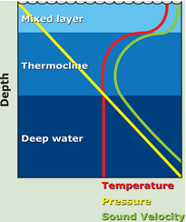

Sound is affected by water much less than light and thus has good penetration properties in water. This allows it to be used for study and communication purposes. The speed of sound is 4 times greater in water than air. The speed of sound increases with increasing temperature and pressure – due to the change in speed (Temperature) or compacting of the water molecules (Pressure).

Above the thermocline increasing pressure with depth increases the speed of sound despite the gradual decrease in temperature.

Within the pycnocline, the speed of sound decreases rapidly because of the rapid decrease in temperature and only slight increase in pressure.

Below the thermocline the speed of sound gradually increases because pressure continues to increase, but temperature only declines slightly.

**c)** Changes in pressure with depth can be calculated using the hydrostatic equation *P = ρgh* where P = pressure, g = gravity = 9.8 m/sec2, h = height and ρ = density kg/m3. Using this equation show how the pressure **(in db)** in the water column increases at the following depths: surface (0m), 125 m, 600 m and finally at 4300 m. Assume that gravity stays the same but that density changes and is the following; 1025 kg/m3 at 0 m, 1026 kg/m3 at 125 m, 1027 kg/m3 at 600 m and 1028 kg/m3 at 4300 m. [12]

**4a)** If all the water in False Bay was evaporated and the salt left behind was spread evenly over Robben Island, how high (m) would this layer of salt be? You have the following information:

Area of False Bay = 750 Km2.

Average water depth of False Bay = 50 m

Average salinity (salt content) of False Bay = 35 g per litre (nb there are 1000 litres in a m3)

Density of salt = 2.2 g per ml (nb there are 1000 ml in a litre). Density = Mass / Volume

Robben Island is approx. 3 Km long and 2 Km wide.

**Hint: Your working units should be metres. The answer is 40 m to the nearest whole number. Clearly show your workings.**

* Volume of false bay in m3 multiplied by 1000, will yield liters in false bay.
* Multiply liters in false bay by 35 to get grams of salt in false bay.
* Divide grams of salt in false bay by 2.2 to yield ml of salt in false bay
* divide ml of salt in false bay by 1000 to get liters of salt in false bay
* divide by 1000 to get m3 of salt
* notice robben island has area of 3000x2000m
* divide m3 of salt by robben island area to get height

**b)** Use a sketch or sketches to demonstrate the effect of a Kelvin wave in the English Channel that results in a high tidal range on the French side and a low tidal range on the English side. Give an example of how the French take advantage of a higher tidal range. [10]

Normandy invasion had to plan around a high-tide that was coming in which allowed allied troops to land further up on the beaches. This would allow infantry less time to be exposed on the beach.

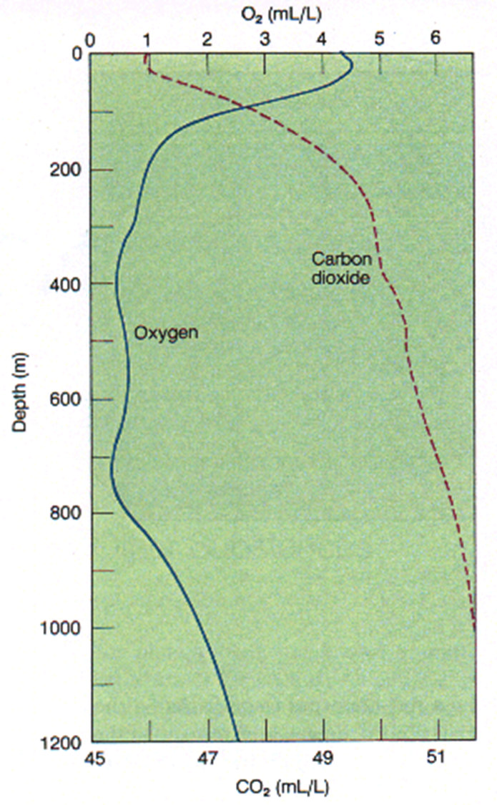**6a)** Draw a vertical profile (i.e., depth on the y axis) of the average concentration of CO2 or dissolved inorganic carbon (DIC) in the ocean. Ensure that you provide units. Briefly explain in terms of ocean physics, chemistry, and biology why the profile is shaped this way.

CO2 concentrations increase with depth because it is used during photosynthesis and released during respiration and because its solubility in water increases with pressure affects PH.

The ocean absorbs CO2 from the atmosphere in an attempt to reach equilibrium by direct air-to-sea exchange. This process takes place at an extremely low rate, measured in hundreds to thousands of years.

Besides the slow pace of ocean turnover, two more factors determine the rate at which the seas take up carbon dioxide. One is the availability of carbonate, which comes from huge deposits of calcite (shells) in the upper levels of the ocean. The ocean’s acidity does rise with increased CO2, but the slow pace of ocean circulation prevents this process from developing useful momentum. It takes a long time for the increased acidity to reach the deep oceans

**b)** Explain how the following changes would affect the profile you drew in (a) above:

i) increasing the rate of macronutrient (i.e., nitrate and phosphate) supply by upwelling to the subtropical (i.e., low latitude) surface ocean where nutrients are currently always completely consumed by phytoplankton.

Phytoplankton utilize photosynthesis which decreases the concentration of CO2. If additional macronutrients were introduced, then we would expect to see a significant increase in the populations of various species of phytoplankton. This would further deplete CO2 in the water as more phytoplankton require CO2 for the photosynthesis process.

ii) increasing the amount of dust deposited in Southern Ocean surface waters.

Dust iron dissolution in seawater introduces a period of fertilization in the ocean that strengthens the Southern Ocean’s biological pump. The biological pump is the part of the oceanic carbon cycle responsible for the cycling of organic matter formed mainly by phytoplankton during photosynthesis (soft-tissue pump), as well as the cycling of calcium carbonate (CaCO3) formed into shells by certain organisms such as plankton and mollusks (carbonate pump). This process decreases surface water carbon concentrations as the carbon is depostied in the sea floor.

**c)** What is the effect of CaCO3 precipitation on:

i) Ocean CO2? Increases, precipitation creates CO2 in net ionic equation

ii) Whole ocean alkalinity? Decreases, acidic process

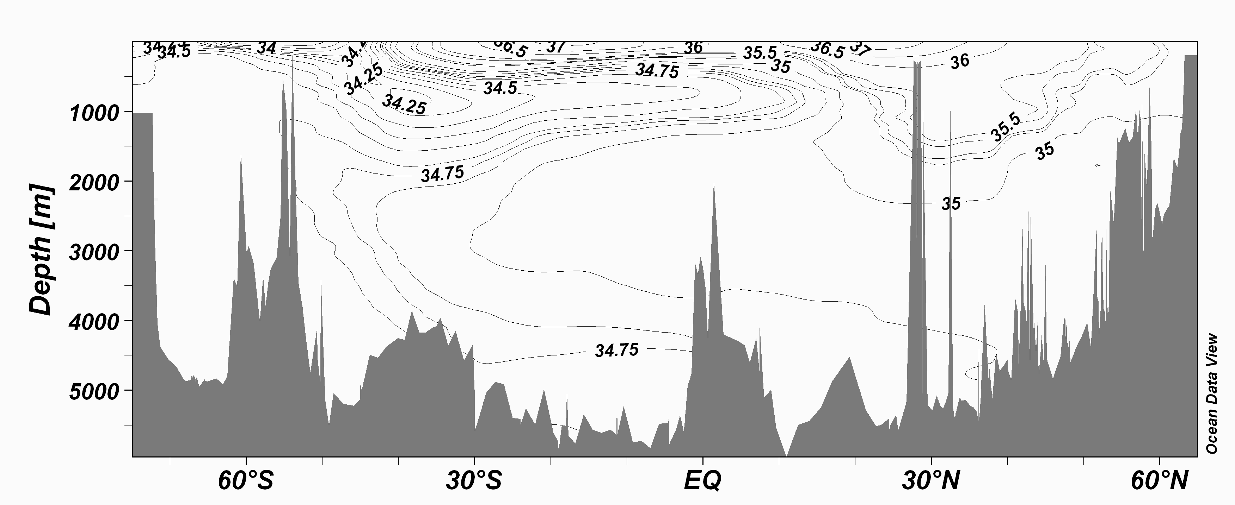

FIGURE 1 – Vertical section showing the distribution of salinity with depth across the entire Atlantic ocean